“Be the Executive Change Strategist of Your Own Life!”
Pro-EFT Radio Show with Lindsay Kenny and Sylvia Becker-Hill 7/20/2011 handout:
To get the best value out of listening to the show, please print this handout and have a pencil ready to fill in the blanks!
- To be the Executive Change Strategist of your own life means:
- You are ____________ to be a change ___________ and not a change _________.
- You choose to take on ______ _______________ for your own experiences.
- You set _________ for different ___________ in your life.
- You make yourself _________________ by measuring your ___________.
- You create a _________ and follow it through.
- You learn from your ____________ and adjust your _______, ________ and ________ .
- Instead of _________ and _________ yourself, you ________ and __________ yourself.
- You focus on the _________, the ________, the _________ .
- You are committed to __________ and _________ .
- You ____________ your results.

- A few change management pearls of wisdom:
- Everything constantly ___________ .
- The Paradox of Change TM: Whatever you want to change, you have first to ______________ it the way it ________ .
- Acknowledgement doesn’t mean you have to _________ it the way it is in the future. It means you label it as it is without ___________. This is: The Rumpelstiltskin Effect TM
- People don’t ________ from not __________ what to do. They suffer from not __________ what they know they ___________ do.
- Often you _______ what you don’t _________. What _________ you are the things you don’t ________ that you don’t _________ them.
- For ___________ ___________ __________ change you need: Brain Alignment TM. Brain Alignment means your ___________ mind AND your ______________ mind are both ____________ together to support you in ____________ your goal.
- Some pearls of wisdom about Your Brain:
- The brain is _________ , it changes _____________ and can change itself till you ____ .
- The conscious mind is _____________ by the ________________ ________ .
- The __________ mind can process only a ______ ________ of information at a time.
- The sub-conscious mind remembers ____________ . It cannot distinguish between ____
and __________ and lives always in the ______ . It also cannot distinguish between ________ and ____________ . For the sub-conscious mind both are the same!
- ____________ is a depletable resource and part of the conscious mind. When you are
tired, stressed, hungry, sick… it gets depleted even _____________ .
- The Iceberg Change Model TM: (see picture on the next third page of this handout)
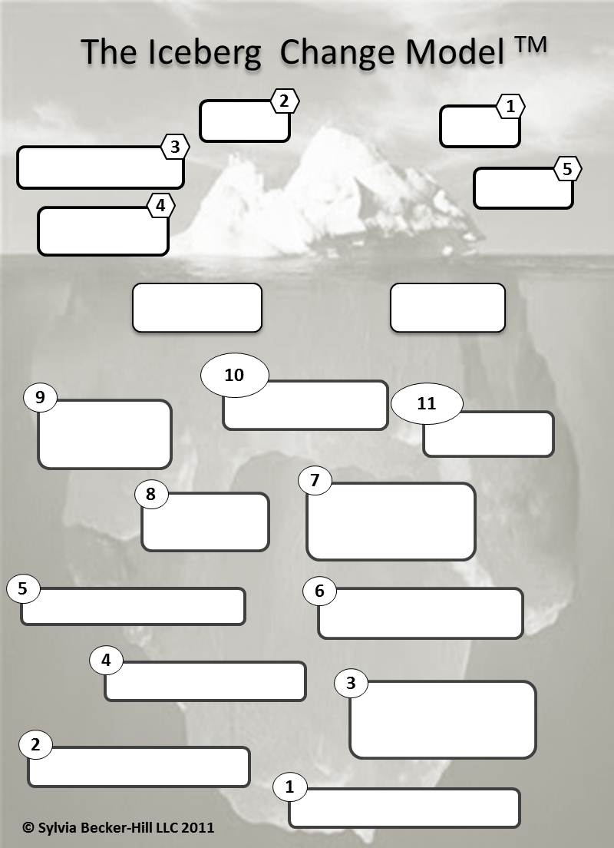
- The insights we want you to take out of this class and remember deeply are:
- Change starts with acknowledging your starting point.
- Brain Alignment TM is the most powerful creative force inside your own brain and Pro-EFT is THE TOOL to achieve it.
- You can change in deeper and more meaningful ways than you have ever imagined!
You can get Sylvia’s free ebook “Resolutions that stick” in which she summarizes all her change management pearls of wisdom from more than 15 years as an executive coach for you by simply signing up for her newsletter here: www.sylviabeckerhill.com/freeebooks
If you like to get inspiration about what’s possible in your life follow Sylvia’s new blog on Facebook: http://www.facebook.com/ItsPossiblebySylviaBeckerHill by clicking on the ‘like’ button.

