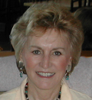
Lindsay Kenny, EFT Master

“My mission in life is to help others create happier, healthier and more effective lives. Becoming a Life Coach helped me realize that purpose. By utilizing 30 years of life experiences and dozens of amazing tools, techniques, and processes, I work with clients to achieve their goals and become all of what they are capable.

“One of my most effective tools is EFT (Emotional Freedom Techniques). EFT helps alleviate negative emotions or past memories that throttle one’s potential. Even though it’s quick and effective, the results are lasting.

“By teaching our clients how to use this simple procedure, we equip them with a tool that can help them become more successful within their relationships, more productive at work, and more accepting of themselves and others.”

Emotional Freedom Techniques….

… Often works where nothing else will
… Usually rapid, long lasting & gentle
… No drugs or equipment involved
… Is completely safe and painless
… Easily learned and used by anyone
… Can be self applied

Emotional Freedom Techniques


The EFT Discovery Statement:
"The cause of all negative emotions is a disruption in the body’s energy system."
Gary Craig, creator of EFT

It is undeniable that negative emotions can greatly impact almost every aspect of our lives. When we are angry, stressed, fearful, depressed, or anxious, it’s difficult to function at our best.

Additionally, negative emotions can cause physical ailments such as headaches, heart palpitations, high blood pressure, ulcers, and more. When EFT is applied (by tapping on specific meridian points while using a specific protocol) the blocked meridians are cleared and the negative emotions are neutralized.

It almost sounds too easy and too good to be true. But it is real. I use EFT everyday myself and utilize it continually in my business, so I know how effective can be. Just read what my clients and others say about EFT:

“I had been having severe migraines for years when one night I was out of medication and at my wit’s end. So I tried the EFT tapping that Lindsay taught me. Within minutes the migraine was completely gone and I haven’t had one since!” Terri S.

*****
“After just one session of EFT my fear of public speaking was completely gone. I’m now calm and confident when speaking.” Roger Terragon

*****

More Testimonials:
“First I should mention how skeptical I was before doing EFT myself. Now I use it all the time for stress and anxiety. It’s a life-saver before difficult meetings or after a tough day at work” John F.
*****
“I couldn’t believe it, but it (EFT) made the pain in my leg go away in just a minute. I thought it was witchcraft. Ha ☺.” Lin P, 86 year-old great grandmother
*****
A Psychiatrist speaks about EFT:
“EFT is the single most effective tool I've learned in 40 years of being a therapist.” Dr. Curtis A. Steele, M.D.

Fears and Phobias:
About 25% of the population suffers from one or more phobias. The intense fear they cause can severely limit the lives of those who suffer with them. There are hundreds of possible phobias and EFT can be effective on all of them. Some of the more common phobias we can help overcome are, fear of:

♦ Public speaking or Rejection
♦ Heights and Claustrophobia
♦ Snakes, Spiders, or Insects
♦ Dentists, Doctors or Needles
♦ Flying or Driving
♦ Failure or Success
♦ Birds, Dogs or other Animals

Weight Loss:
67% of all Americans are 30 pounds or more overweight! One of the reasons Diets don’t work is that weight gain is often emotionally based. We show clients how to lose weight safely, easily and without being hungry. And, we teach them how to keep it off for good!

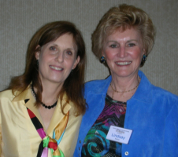
Zoe and Lindsay

In Summary:
In addition to private coaching sessions Lindsay teaches EFT workshops. She and her co-facilitator, Zoe Walton, offer Levels 1-3 in the San Francisco Bay Area. They believe that teaching EFT to the public provides them with a tool that can help them through a lifetime of issues.

The Level 1 course can teach you how to use EFT in a fun, interesting and easy way. Levels 2 and 3 help you take EFT to a higher level while providing you with the skills and abilities to use EFT with others. CEUs are offered for RNs, Acupuncturists MFTs, and LCSWs.

Regardless of how you learn EFT it can offer you what it takes to experience a healthier, happier, and more peaceful life.

www.LKcoaching.com
www.EFTworkshops.org
e-mail: LKCoaching-Linz@yahoo.com

415-507-0888
8 – 6 PST
888-449-3030
voice mail 24/7

Lindsay Kenny
San Francisco & San Rafael, CA

For appointments e-mail: assistant@LKcoaching.com

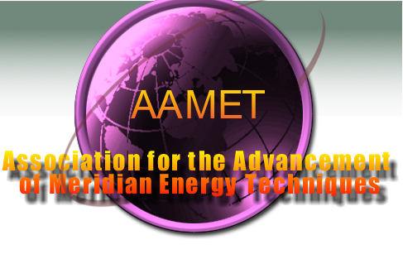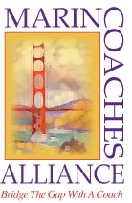

Lindsay is a Certified AAMET Trainer, and a member of the Marin Coaches Alliance and the...



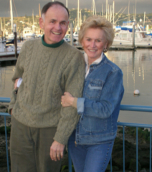
Jack and Lindsay Kenny

©2006 by LK Enterprises

Helping Others Achieve More Joyful, Peaceful, and Productive Lives

Assisting clients to conquer:
♦ Stress, Anxiety & Fear
♦ Frustration, Guilt & Anger
♦ Depression & Grief
♦ Addictions & Cravings

Helping people overcome:
♦ Weight Issues
♦ Limiting Beliefs & Self Doubt
♦ Migraines & Chronic Pain
♦ Past Traumatic Issues

Learning how to improve:
♦ Personal & Effectiveness
♦ Sports Performance
♦ Self Esteem & Confidence
♦ Emotional & Physical Health

“Life Coaches…God bless you if you hire one or become one.” Excerpt from “Ten Reasons to Feel Good about the Future” by Martha Beck, in the March 2004 issue of O Oprah Magazine

